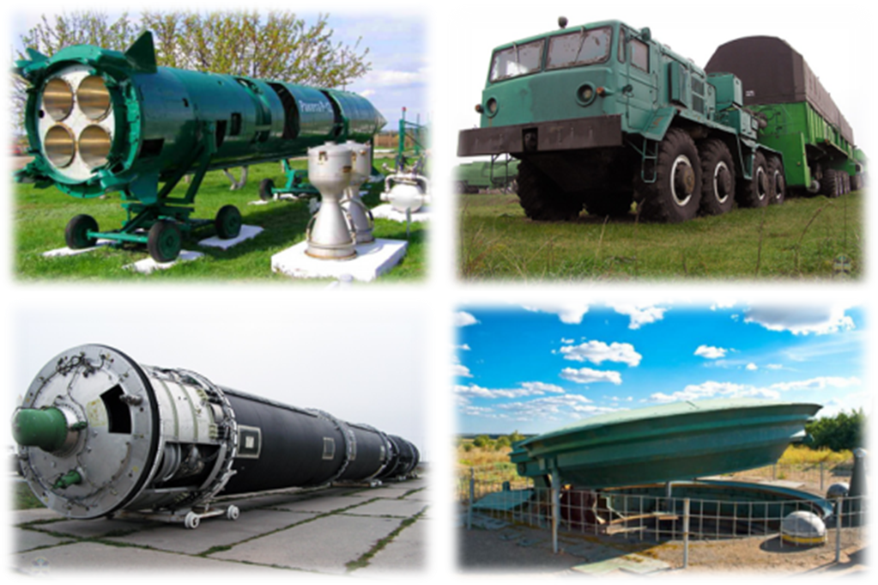
Adventure weekend in Ukraine:
Riding on armored reconnaissance patrol car, visiting Museum of Missile Forces and excursion to Chernobyl!
Guide services in English throughout the route!
Duration: 5 days / 4 nights
Itinerary: City tour around Kiev–Kiev bar crawls-Andreevsky Descent–food tasting "Ukraine hospitable" – Residence of the former president of Ukraine Mezhyhirye - experience of riding on armored military vehicle - Museum of History of Ukraine in World War II – Kievo-Pecherskaya Lavra
2nd day of the program has options to choose from!
Tour program:
Day 1
Arrival to Kiev. Meeting at the airport. Transfer to the city.
Lunch at the Ukrainian folk style cafe.
Your Сity-tour around Kiev is beginning!
Kiev is more than one and a half thousand years old. Antiquity and modernity miraculously coexist on its streets. You will be surprised by the most interesting sights of the city, which marked the main pages of its history: Old Kiev mountain, a stone with the inscription "where did the Russian Land come from", The famous Golden Gate, St. Sophia Cathedral, St. Vladimir's Cathedral, St. Andrew's Church and St. Michael's Cathedral, The Pechersk Lavra. We will admire the temples of Podol and the aristocratic mansions of Pechersk, we will go through the centuries-old history of the city and will see modern face of Kiev as well.
Check-in to the hotel. A little time for rest.
Delicious dinner in the city cafe. To make your evening even more fun – we are going for the bar crawl afterwards. We will visit 5 bars of the city, accompanied by a connoisseur of the most interesting cocktails of the Ukrainian capital. It will be an unforgettable experience. Such an emotional, bright, unusual evening for your team will be remembered for a long time!
Return to the hotel. Overnight stay.
Day 2
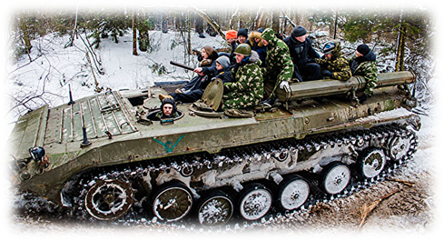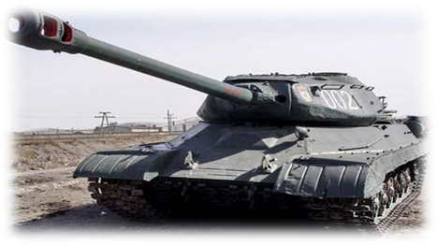
Option number 1 (for the whole day)
Breakfast at the hotel. Departure from Kiev.
Transfer to the Museum of the Missile Forces of Ukraine (295 km trip).
Briefing, safety instructions.
Riding on military vehicles BRDM (soviet armored reconnaissance patrol car) , GTSM – ARROW (soviet military caterpillar all-terrain vehicle, modernized) Tank IS-4 1944 (about 30 min).
Off-road riding on top of the vehicles (forest, picturesque places, extreme paths). Driving the vehicles.
Excursion to the museum of the Strategic Missile Forces.
At will, it is possible to organize shooting at a rifle range.
Dinner.
Departure to Kiev.
21:00 Arrival to the capital.
Free time. On request, it is possible to organize an evening program (visiting night clubs). Overnight at the hotel.
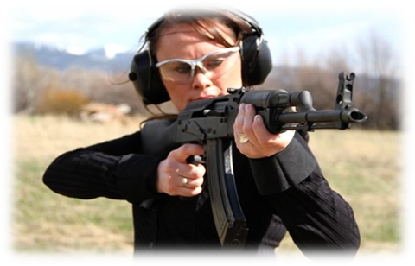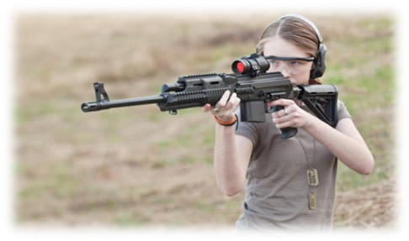

Option number 2 (half a day)
Breakfast in the hotel. Departure from Kiev.
Transfer 25 km from Kiev.
Briefing, safety instructions.
Riding in military vehicles BRDM-2 (soviet armored reconnaissance patrol car) (about 30 minutes)
Off-road riding on top of the vehicles (forest, scenic spots, extreme paths)
BRDM - 2 driving
Shooting from Kalashnikov, SVD-Dragunov ( Dragunov sniper rifle) (optional).
Dinner.
16:00 return to Kiev.
Free time for your leisure.
Overnight at the hotel.
Day 3
Breakfast in the hotel.
Since the morning we will go on an excursion along Andreevsky Descent. Andreevsky Descent is one of the oldest and the most favorite streets for Kiev’s inhabitants and visitors of the city. Novels can be written about it (which was done by one of its admirers). Such famous writers, as Mikhail Bulgakov and Viktor Nekrasov, Mikhail Vrubel, doctor Theofil Gavrilovich Yanovskiy were residents of Andreevsky descent. Walking along this street-museum , will let you hear their voices, telling you the extraordinary stories about the Andreevsky Descent.
After that – there will be more fun!. We will go to lunch – tasting of Ukrainian cuisine "Ukraine hospitable".
Such a dinner will be remembered for a long time! Under the sound of Ukrainian music and the clinking of glasses, we will all shout traditional Ukrainian toast "Bud'mo! Hey, Hey, Hey. "
After the delicious lunch, we will go on an excursion to the former residence of the President of Ukraine - Mezhyhiriya, that is famous for it’s well-groomed park area, decorative lakes with fountains, fresh air, openwork bridges. You will be impressed by the ostentatious luxury of the former residence of Yanukovych. You will see the famous Honka, Spa center, golf course, the magnificent Galleon ship. We will walk 3 km along the shore of the Kiev Sea. You will hear fascinating stories about the expulsion of monks from Mezhihirsky Hills. Should you go to Mezhyhiriya today? Yes! Our tourists, who have already visited there, all say as one: "We want to return here again. Mezhyhiria is seen as the National Park of Ukraine! "This area has a very deep historical past.
Return to Kiev.
Time for a conference at the hotel.
Dinner. Overnight stay.
Day 4
Breakfast in the hotel. Departure to Chernobyl abandoned zone.
10.30-11.00 Passage through the checkpoint "Dityatki" on the verge of a 30-kilometer zone (exclusion zone and the zone of compulsory resettlement), passport control, instruction on radiation safety rules and informative conversation with a specialist of the State Enterprise "TSOTIZ", checking of the insurance documents.
Note. During the conversation, visitors will receive brief information about the exclusion zone (including the Chernobyl NPP), its problems, will hear about the main areas of work that are carried out currently in the exclusion zone by enterprises of the GAZO.
11.30-14.00 A sightseeing trip to the 10-kilometer zone.
Along the route: Chernobyl (monument to "To Those, Who Saved the World") - Checkpoint "Lelev" - transfer to the Chernobyl NPP through the burried village of Kopachi – drive around the NPP with the stop at the view point of “Shelter” (Sarcophagus) – visit of the viewing pavilion – transfer to the dead town of Prypyat- tour around Prypyat (without entering buildings) – object Chernobyl 2- Lelev checkpoint (dosimetric control)- transfer to Chernobyl .
14.00 tour around Chernobyl (Svyato-Illiinsly Temple, memprial complex “Star Polyn”, place of stay of the samples of the vehicles, that were used during the liquidation of consequences of the accident on Chernobyl NPP.
16.00 Dinner at the café in Chernobyl. (ecological purity of the food is guaranteed) . 16.45 – departure from Chernobyl. 17.00 Passing checkpoint “Dytyatki”.
19.00-20.00 Return to Kiev. Dinner at the hotel’s restaurant. At your will, an entertaining program can be organized. Also, you may just dedicate that night to discovering Kiev’s night clubs and discos.
Day 5
Breakfast at the hotel. Check out.
Visit to the one of the most famous symbols of Kiev and Ukraine - the monument "Monument to the Motherland" - the Museum of Ukrainian History in World War II. A colossal 62-meter statue of Motherland (102 m with pedestal) is made of special stainless steel and assembled with a special crane. The memorial complex "Museum of the History of Ukraine in World War II" occupies 10 hectares on the hill of the right bank of the Dnieper river. It contains a giant bowl of the Eternal Flame, an exhibition of military equipment from the time of World War II, as well as post-war years, the alley of the Heroic Cities.
Your acquaintance with the capital of Ukraine will be finished with a visit to the Kiev-Pechersk Lavra.
Here, everyone finds what they are looking for, what they are striving for: religious people find temples, holy relics in caves, communication with the monastery's inhabitants; lovers of antiquity - the oldest historical monuments; admirers of the beauty- an amazing architectural ensemble, in combination with the beauty of nature and unusual landscape.
Lunch in the city cafe. Airport transfer. Departure.

The cost of the program:
Prices are per person, in USD:
Hotels | 10+1 | 15+1 | 20+1 | 25+1 | 30+1 | 35+1 | 40+1
Hotels | $ | $ | $ | $ | $ | $ | $
Kiev 3 *  Raziohotel Yamskaya 3* | 470 | 419 | 400 | 395 | 385 | 371 | 365
Кiev 4 *  BAKKARA 4* | 515 | 463 | 444 | 438 | 427 | 413 | 407
Кiev 4 * +  Cosmopolite 4*+ | 585 | 532 | 511 | 400 | 494 | 479 | 473
Кiev5 *  Fairmont Grand Hotel 5* | 867 | 808 | 783 | 775 | 761 | 745 | 738
*the hotels may be replaced by equal, in the same category

Included in cost:
• 4 nights at the hotel in Kiev
• 4 breakfasts, 5 lunches, 4 dinners
• Transportation service according to the program
• English speaking guide
• Excursion program with entrance tickets according to the program
• Bar crawl in Kiev
Not included in cost:
Prices are per person, in USD:
Programs: | 10+1 | 15+1 | 20+1 | 25+1 | 30+1 | 35+1 | 40+1
Programs: | $ | $ | $ | $ | $ | $ | $
2nd day:  Option number 1 (for the whole day) | 125 | 114 | 95 | 92 | 89 | 86 | 85
2nd day:  Option number 2 (half a day) | 70 | 65 | 60 | 57 | 55 | 50 | 45

